Two-Point Threshold Lab
Procedure
Working with a friend you are going to test each other's two-point threshold. A two-point threshold test seeks to find at what distance apart does a person perceive one point as two separate points. To test this, two points start together touching the skin. Incrementally they are pulled further apart and reapplied to the skin until the subject can clearly tell there are two different points.

You will take measurements from the following different body part locations: back of hand, palm of hand, back of neck, sole of foot, back of calf, and forearm. You will perform this experiment twice (ascending and descending with the markers). Finally, the test subject must always keep their eyes closed!

Materials:
- Two markers
- Ruler
- Separate sheet of paper for your answers

Directions
- Have your partner close their eyes and sit in a chair with a table in front of them. Then your partner places their arm on the table with their palm facing up. Start by measuring the 2-point threshold of the finger tip
- Touch the two markers to one point on their fingertip and ask them if they feel one point or two points. They should say one point. Remove the markers and increase the distance between them slightly (about 2 mm). Touch both tips at the same time, and ask again. If they still only feel one point, increase by another 2 mm and reapply.
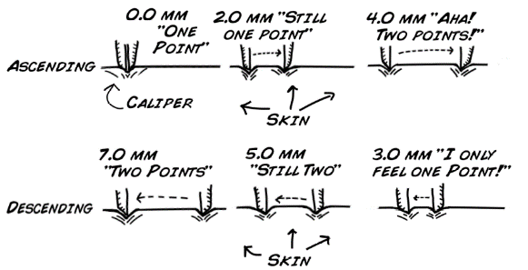
- Continue this cycle until your partner feels two points. Measure the distance between the two points with a ruler and record the millimeter measurement in the chart below.
- Do this test again for the back of hand, palm of hand, back of neck, sole of foot, back of calf, and forearm (posterior)
- Switch positions of experimenter and subject; run the test again.
- After you have both tested each other run the whole experiment again (Steps 1 to 5); however, this time you will start at a large distance apart and descend from 2 points until your partner can only feel one point.
  - For example, if your partner could tell that one point became two points at 6 mm on their finger tip, start the descending experiment at 10 mm. This ensures that your partner will feel two different points.

 | Fingertip | Back of Hand | Palm of Hand | Back of Neck | Sole of Foot | Back of Calf | Forearm
Descending
Ascending
Average (mm)
Questions:
- Why can your fingertip detect such small distances between points while your arms and legs cannot?
- Would you expect to see a difference in males vs. females for the four recorded areas? What about children vs adults?
- Why doesn't your brain have the sensitivity of your fingertips all over your body?

Two-Point Threshold Lab
Procedure
Working with a friend you are going to test each other's two-point threshold. A two-point threshold test seeks to find at what distance apart does a person perceive one point as two separate points. To test this, two points start together touching the skin. Incrementally they are pulled further apart and reapplied to the skin until the subject can clearly tell there are two different points.

You will take measurements from the following different body part locations: back of hand, palm of hand, back of neck, sole of foot, back of calf, and forearm. You will perform this experiment twice (ascending and descending with the markers). Finally, the test subject must always keep their eyes closed!

Materials:
- Two markers
- Ruler
- Separate sheet of paper for your answers

Directions
- Have your partner close their eyes and sit in a chair with a table in front of them. Then your partner places their arm on the table with their palm facing up. Start by measuring the 2-point threshold of the finger tip
- Touch the two markers to one point on their fingertip and ask them if they feel one point or two points. They should say one point. Remove the markers and increase the distance between them slightly (about 2 mm). Touch both tips at the same time, and ask again. If they still only feel one point, increase by another 2 mm and reapply.
- Continue this cycle until your partner feels two points. Measure the distance between the two points with a ruler and record the millimeter measurement in the chart below.
- Do this test again for the back of hand, palm of hand, back of neck, sole of foot, back of calf, and forearm (posterior)
- Switch positions of experimenter and subject; run the test again.
- After you have both tested each other run the whole experiment again (Steps 1 to 5); however, this time you will start at a large distance apart and descend from 2 points until your partner can only feel one point.
  - For example, if your partner could tell that one point became two points at 6 mm on their finger tip, start the descending experiment at 10 mm. This ensures that your partner will feel two different points.

 |  | Fingertip | Back of Hand | Palm of Hand | Back of Neck | Sole of Foot | Back of Calf | Forearm
Descending
Ascending
Average (mm)
Questions:
- Why can your fingertip detect such small distances between points while your arms and legs cannot?
- Would you expect to see a difference in males vs. females for the four recorded areas? What about children vs adults?
- Why doesn't your brain have the sensitivity of your fingertips all over your body?

