Cardiovascular System Packet o’ Knowledge
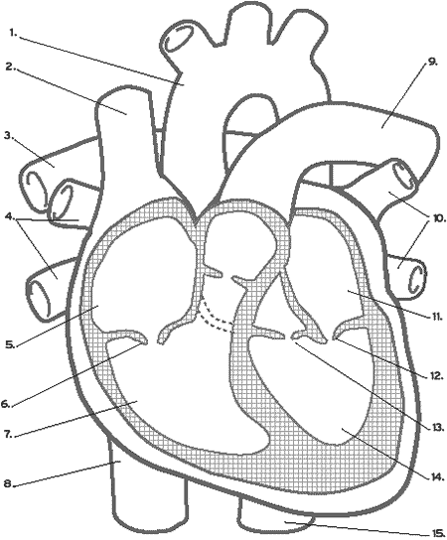

- Label the following: right atrium, right ventricle, left atrium, left ventricle, ascending aorta, descending aorta, right pulmonary trunk/artery, left pulmonary trunk/artery, left pulmonary veins, right pulmonary veins, bicuspid valve, tricuspid valve, superior vena cava, inferior vena cava, aortic valve
- Using blue and red pen/marker/colored pencil/crayon, outline the flow of blood through the body. Mention where it goes when it leaves the heart.

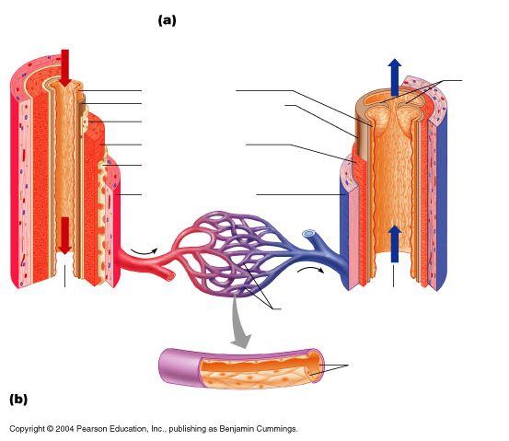
Label the following: tunica intima, tunica externa, capillary network, vein, artery, valve, lumen, tunica media, internal elastic lamina, external elastic lamina, endothelial cells, subendothelial layer
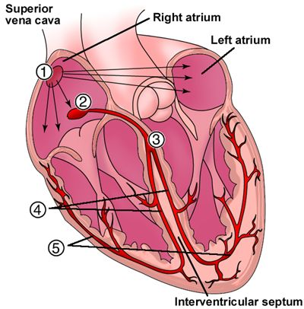
Using the numbers on the heart above, write the process of the intrinsic conduction system beginning with the SA node and ending in Purkinje fibers.
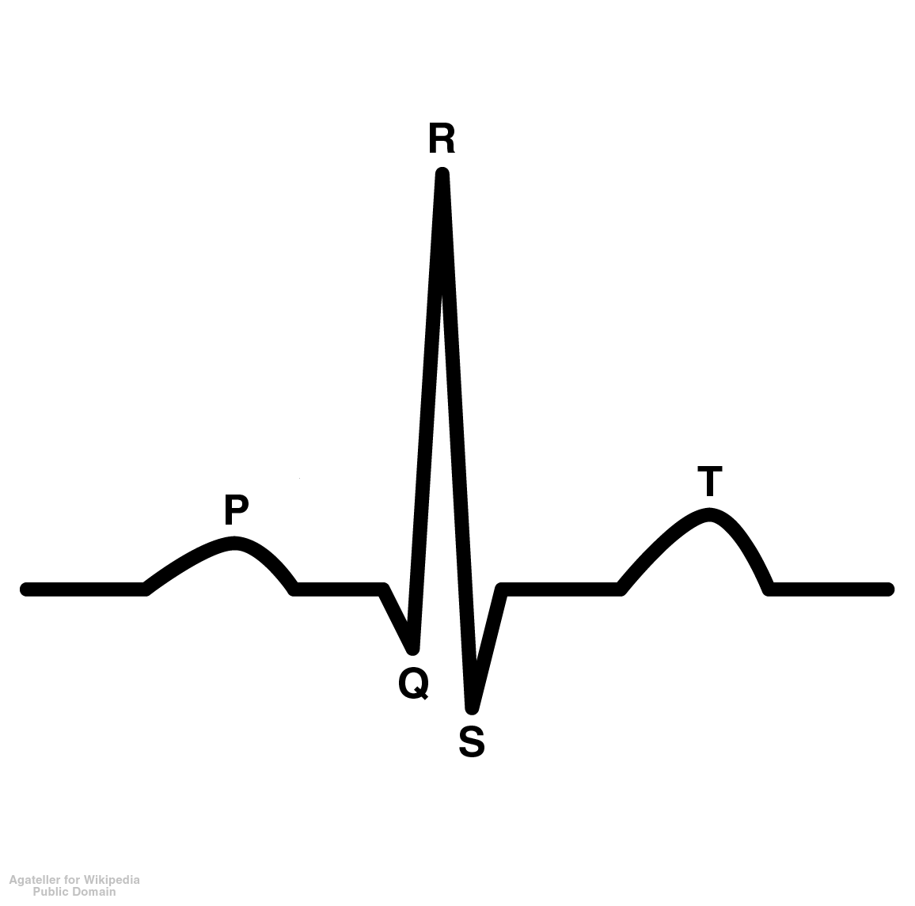
Using the EKG, describe what events are occurring at each wave

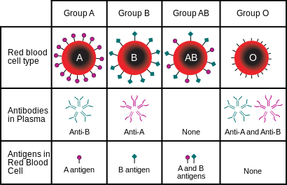
Fill in blanks in this chart

Calculate the following problems:
Cardiac Output= Stroke Volume + Heart Rate
- Heart Rate= 72 bpm, Stroke Volume= 70 ml

- Heart Rate= 100 bpm, Stroke Volume= 90 ml

- Cardiac Output= 6000 ml/min, Heart Rate= 90 bpm

