Appendages of Skin
Name | Notes | Identification
Eccrine Sweat Glands | - releases _________ (99% water, salts, vitamin C, antibodies, wastes)  - Abundant on palms, soles of feet, forehead  - ____________________ | 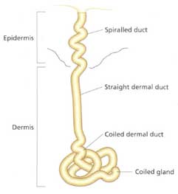
Apocrine Sweat Glands | - Sweat + fatty substances & proteins → milky/yellowish  - With bacteria = ____________  - Activated at puberty → ____________________ | 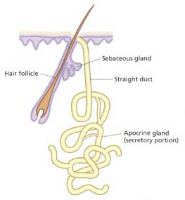
Sebaceous Glands | - Secrete oil (_________) into the hair follicle  - Waterproofing skin  - Soften & __________ hair, skin  - Kills bacteria  - _________- active inflammation of sebaceous glands caused by bacterial infection (staph) | 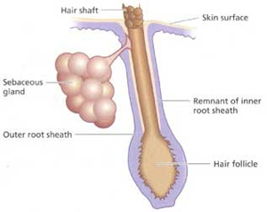  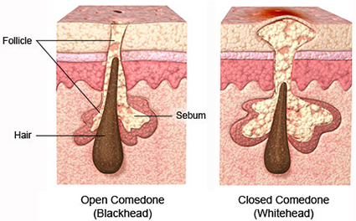
- _________- active inflammation of sebaceous glands caused by bacterial infection (staph)
- Treatment:
  - Reduce ___________
  - Speed up skin cell turnover (prevent plugged follicles)
  - Fight ______________
  - Reduce ___________
- ____________ = blocked sebaceous gland
- _____________ = sebum oxidizes and dries
Hair (Pili) | - 2 main regions: ___________ & hair shaft  - Project from follicles in __________  - Consists of dead, keratinized cells  - ___________ pili (smooth muscles) attached to hair root → pulls hair upright | 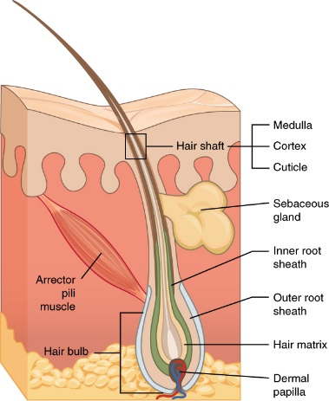
Nails | - Grows from nail matrix  - Visible part of nail is _________________  - Cuticle covers nail root  - Contains hard __________ | 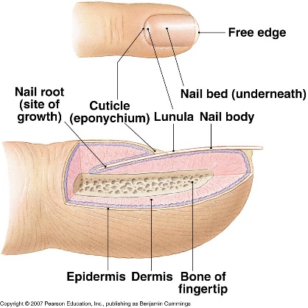

Skin Pigments
Melanin- brown/black or ____________________ | - Made by ________________  - Only found in deeper layers of epidermis  - Freckles & moles = local accumulations of melanin  - Protect DNA from __________________
Carotene- yellow-_______________ | - Accumulate in _________________, hypodermis  - Carotene converts to _____________ in body  - Asians: yellowish skin = melanin + carotene
Hemoglobin- _______________ blue | - Red blood cells in capillaries

Homeostatic Imbalances:
- Cyanosis: poorly oxygenated blood, blue color
- Excessive sun exposure: leathery skin, rashes, ______________
- ____________: blushing, fever, allergy, inflammation, hypertension (high BP)
- Pale skin (pallor): anemia, low blood pressure, fear, anger
- Jaundice (yellow cast): liver disorder (bile pigments = bilirubin)
- _________________: Addison’s disease, pituitary gland tumors
- Bruises: blood clots under skin

