Integumentary System- skin and its derivatives (sweat & oil glands, hair, nails)
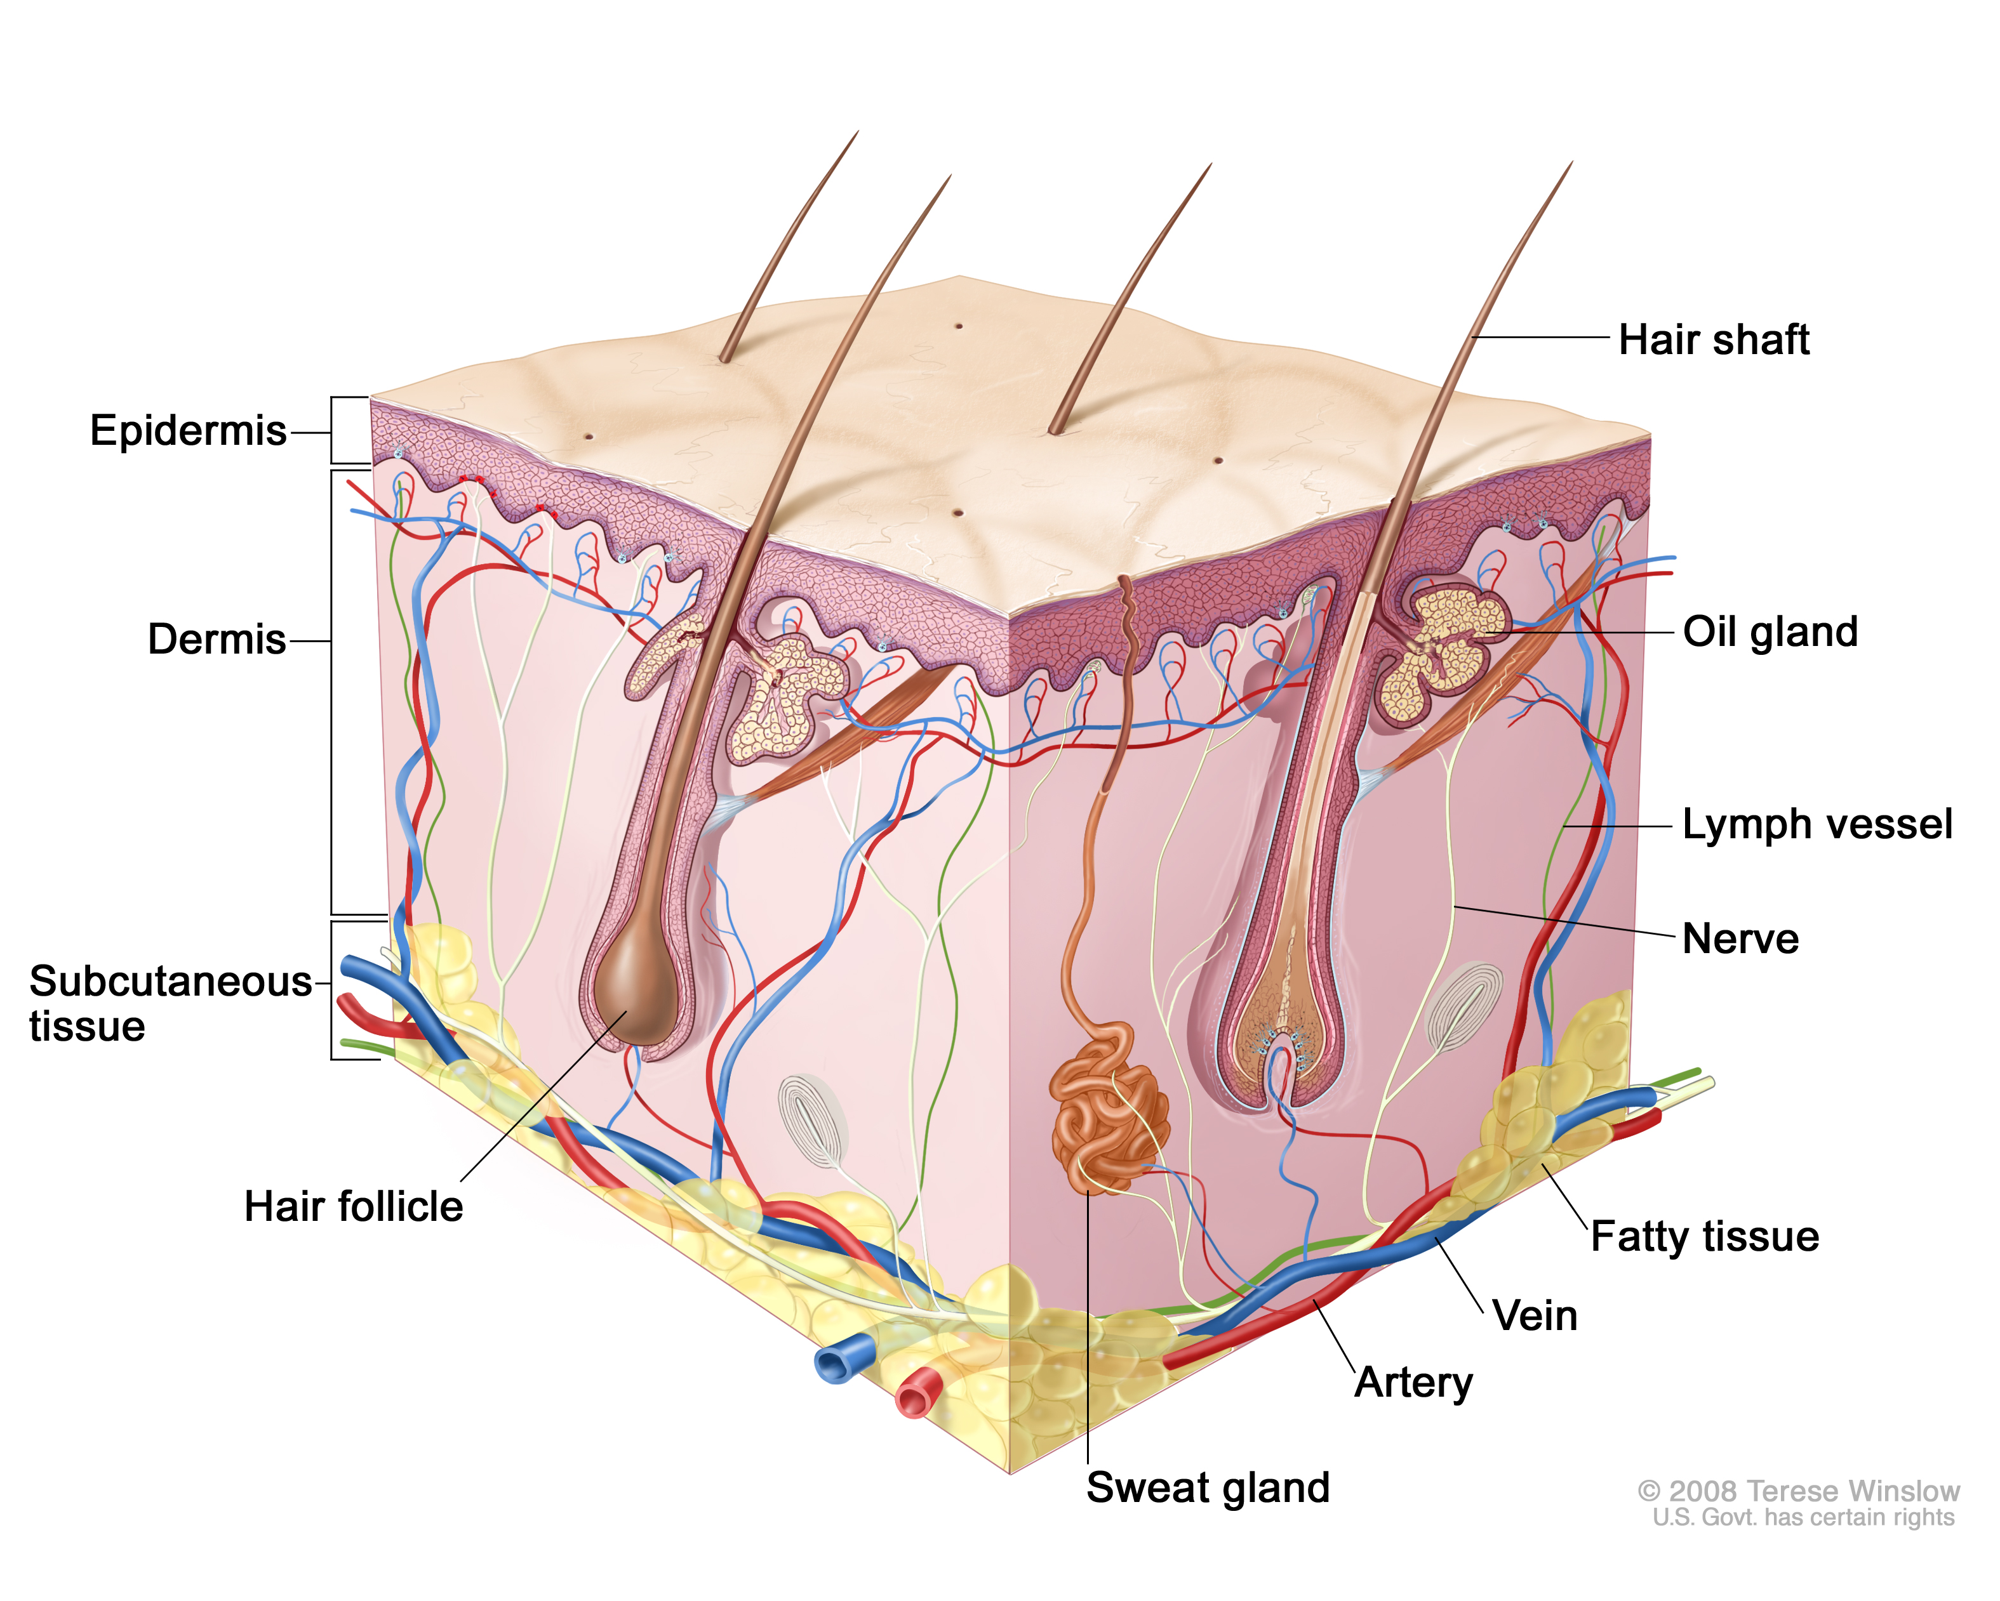
Basic Functions of the Skin
- Protection from:
  - _____________ damage (bumps & cuts)
  - Chemical damage (acids & bases)
  - _________ damage (heat/cold)
  - Bacteria
  - UV radiation
  - Desiccation (drying out)
- Temperature regulation (sweat glands)
- Excrete urea
- Synthesize Vitamin D
- ______________
- Sensory reception (touch, heat, pain, pressure)
Fibers
- Collagen: give skin strength; binds __________ (hydrate skin)
- Elastic fibers: stretch-recoil properties of skin
- ________________: fewer fibers, less subcutaneous fat → skin loses elasticity and sags/wrinkles
- Extreme stretching of skin (_____________): dermal tearing leaves white scars = “stretch marks”
Structure of the Skin
- Two regions:
  - _____________ – keratinized stratified squamous epithelium
  - Dermis – fibrous connective tissue
Epidermis
Cells of the epidermis:
- Keratinocytes
  - Produce keratin = fibrous protein
  - Growth starts in deepest epidermal layer (stratum basale) → pushed upward by new cells underneath
  - Top layer = dead, scalelike structures
- Melanocytes
  - Produce melanin = pigment (yellow/brown/black)
  - Melanin granules taken up by nearby keratinocytes
  - Shields DNA from UV radiation
Layers of the epidermis (superficial to deep)
Stratum corneum (horny layer) | - “Overcoat” for body  - Protect against abrasion, penetration, & water loss (_________ & glycolipids)  - 20-30 cells thick  - Shingle-like ______________
Stratum lucidum (clear layer) | - Clear, flat, dead cells  - Thick layer on ______________, soles of feet
Stratum granulosum (granular layer) | - Cells become flatter, full of keratin  - Water-resistant ___________ fills spaces
Stratum spinosum (prickly layer) | - Thick bundles of _______________  - Abundant melanin granules
Stratum basale (basal layer) | - Single row of stem cells  - Receive nutrients from dermis  - Rapid _________________
Dermis
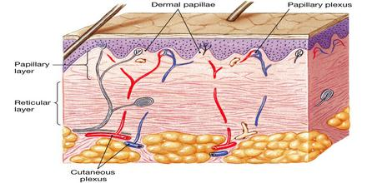
- Strong, flexible _______________________
- Semi-fluid matrix with fibers (collagen, elastic)
- Leather “hide” of animals
- Contains:
  - nerve fibers
  - blood vessels
  - lymph vessels
  - _________________
  - oil glands
  - _________________
- Cells: fibroblasts, macrophages, mast cells, WBC’s
Layers of Dermis
Papillary layer | - Upper part of dermis  - Dermal _____________ = peg-like projections  - Contain capillary loops  - Free nerve endings  - Touch receptors (__________________)  - Forms ridges (large mounds) → increases friction to enhance gripping ability on fingers & feet  - Friction ridge pattern = _________________
Reticular layer | - _____________ skin layer  - Dense, fibrous connective tissue  - Contains blood vessels, sweat & oil glands, ____________________ (Pacinian corpuscles), WBC’s  - Collagen fibers in bundles form cleavage (tension) lines  - Incisions made parallel to line heal more readily

Other Information
- Blister: separation of ___________ and dermal layers
- Blood vessels in dermis: maintain body temp.
  - Cooling: Capillaries swell with heated blood → skin becomes red and warm → radiate heat
  - Conserve heat: blood bypasses capillaries to skin
- Bedsores: if __________ (O2) is restricted to cells → skin cells die & cause ulcers
  - Bedridden patients need to be turned regularly (ubiquitous ulcer)
- Tattoos: deposit pigment within ___________

