Skin Cancer:
- Affects 1 in 5 Americans
- Caused by UV damage to DNA
Type | Class Notes | My Notes
Basal cell carcinoma | Least malignant, most common (80% skin cancers)  ________________  Sun-exposed areas of face  Shiny, dome-shaped nodules  _______________; rarely metastasizes (spreads)  Removal by surgery (99% cases)
Squamous cell carcinoma | 2nd most common  Keratinocytes of _____________________  Scaly, reddened bump  Grows rapidly and can metastasize if not removed  Removal by ________________________________
Melanoma | Most dangerous  Highly metastatic, resistant to __________________  1/3 from moles (spreading brown→black patch)  Key = ______________________!!!  Surgery + immunotherapy

A B C D E
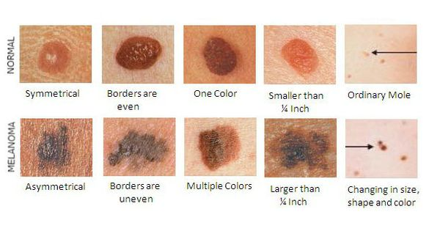

Burns:
Tissue damage caused by ______________, electricity, radiation, _________________
- Main threat: loss of fluids (dehydration, electrolyte imbalance)
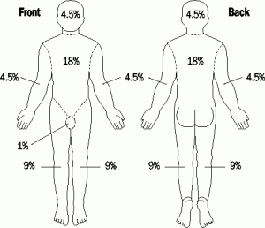
- Kidney failure, circulatory shock
- Treatment: replace fluids via IV
Rule of Nines: estimating extent of burns
- Divide body into ___________ areas
- Each part is 9% of total body area + 1% genital region
Critical burns
- >25% of body with 2nd degree burns
- >10% of body with __________ degree burns
- 3rd degree burns on face, hands, feet
- Face: swelling of respiratory passages → suffocation
- Joints: scar tissue formation limits ________________

First Degree: only epidermis damaged → swelling, redness, pain (______________) | Second Degree: injure epidermis & upper dermis → ____________________; blisters | Third Degree: entire thickness of skin, destroy nerve endings (no pain) → _____________  ___________________
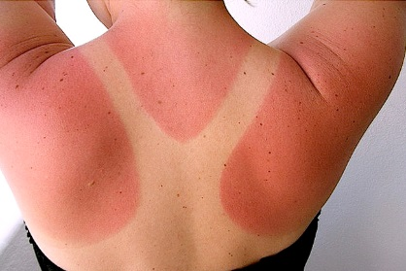 | 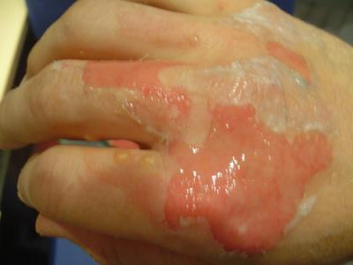 | 