IIFYM (If it Fits your Macronutrients) 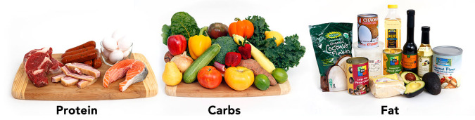
Purpose: Nutrition is a vital part to maintaining a healthy digestive system. It is important to make sure we’re aware of what we’re putting in our bodies to ensure our cells are obtaining the nutrients they need to function efficiently. Determining macronutrient levels is a good place to start in determining the amount of types of food you need to consume. Macronutrients include carbohydrates, fats, and protein. Our bodies need a certain amount of each every day to maintain homeostasis.
Pre Research Questions:
1. What is the function of each of the macronutrients? What do they provide our bodies with?
Carbs:
Fats:
Proteins:
2. What are some sources of each macronutrient? Choose foods that you’ve eaten recently.
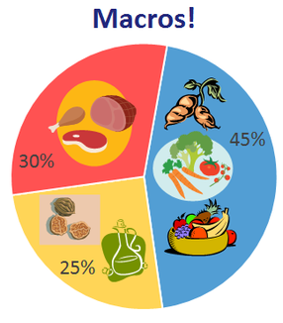
Carbs:
Fats:
Proteins:
3. Define metabolism.
4. Where do we metabolize each macronutrient?
Carbs:
Fats:
Proteins:

PART ONE: On a Chromebook, google “IIFYM calculator.” Follow the instructions on the website and determine your macronutrient levels. You will do this for TWO different websites. If you don’t know some information, like lean body mass or fat percentage, then guess or make up a number. Just make sure to keep it consistent.
**If the website asks, keep percentages at 50% carbohydrates, 25% protein, 25% fat
Website 1:
Maintain/Gain/Lose Activity Level: TDEE: BMR:
 | Carbohydrates: | Fats: | Protein:
Calories |  |  |  | Total Calories:
Grams

Daily Percentage |  |  |  | =100%

Website 2:
Maintain/Gain/Lose Activity Level: TDEE: BMR:
 | Carbohydrates: | Fats: | Protein:
Calories |  |  |  | Total Calories:
Grams

Daily Percentage |  |  |  | =100%

1. Did you see differences between your macronutrient breakdown? How would you explain them?
2. What does TDEE stand for? BMR? (You might have to google these.)
PART 2: Go to https://healthyeater.com/how-to-calculate-your-macros and read through the steps to calculating your macros. Follow the procedure using your information and show your work below.

1. Did you end up with similar numbers as the website calculators? Explain the reason for possible differences.
2. How many calories of energy do you get per gram of carbohydrate? Fat? Protein?
3. Explain why your body prefers to use carbohydrates as energy

PART 3: Think of everything you ate yesterday. Write down each food item and estimate how many calories and macronutrients it contained. You might need to search on the internet for this information in pieces (Example: ham and cheese sandwich: I’d google the calories in bread, cheese, and ham separately and add them up).
Breakfast:
Food | Carbohydrates (kcal) | Fats (kcal) | Proteins (kcal) | Total Calories

Lunch:
Food | Carbohydrates (kcal) | Fats (kcal) | Proteins (kcal) | Total Calories

Dinner:
Food | Carbohydrates (kcal) | Fats (kcal) | Proteins (kcal) | Total Calories

Snacks:
Food | Carbohydrates (kcal) | Fats (kcal) | Proteins (kcal) | Total Calories

1. Did your diet yesterday fall within your macronutrients?
2. How could you have changed your diet to better fit your macronutrients?
3. Why might tracking macronutrients be a beneficial practice?
4. Would you consider tracking your macronutrients? Why or why not?

