Joints- Where two or more bones meet
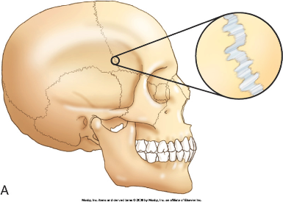
Functions: ______________________________________________
Classified by ________________ (or function):
- Fibrous (synarthroses): ________________ joint
- Cartilaginous (amphiarthroses): slightly movable
- ________________ (diarthroses): freely movable
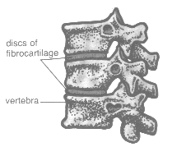
Fibrous Joints:
- No movement
- Location:
Cartilaginous Joints:
- Bones united by _______________________
- Location: epiphyseal plates, rib, and sternum, pubic symphysis
Synovial Joints:
- Bones separated by fluid-containing joint cavity
- Synovial fluid reduces friction between cartilages
- ________________: fibrocartilage that partially divides a joint cavity at knee, reduces friction
- ________________: flattened sacs containing synovial fluid, occur where bones, ligaments, tendons, muscles, skin rub together
Synovial Joint | Movement | Location
Plane
Hinge
Pivot
Condyloid (ellipsoidal)
Saddle
Ball-and-socket

Synovial Joint Movement:
Movement | Description | Example/Picture/Reminder
Gliding
Angular | Flexion:  Extension:  Abduction:  Adduction:  Circumduction: | Flexion:  Extension:  Abduction:  Adduction:  Circumduction:
Rotation
Special Movements | Supination:  Pronation:  Elevation/Depression:  Inversion/Eversion:  Dosiflexion/plantar function:  Protraction/retraction:  Opposition: | Supination:  Pronation:  Elevation/Depression:  Inversion/Eversion:  Dosiflexion/plantar function:  Protraction/retraction:  Opposition:

