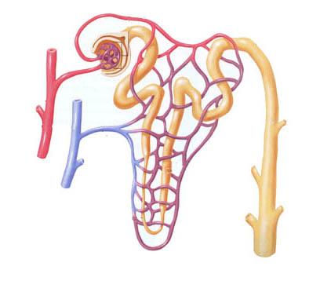Name:__________

Urine Production

Aldosterone

Renin

Antidiuretic Hormone (ADH)

Calcitriol

Angiotensin II

Draw a picture of your kidney here:

Label the following:

* Renal cortex
* Renal medulla
* Renal pelvis
* Medullary pyramids
* Renal artery/vein
* Ureter
* Calyx