Mitosis
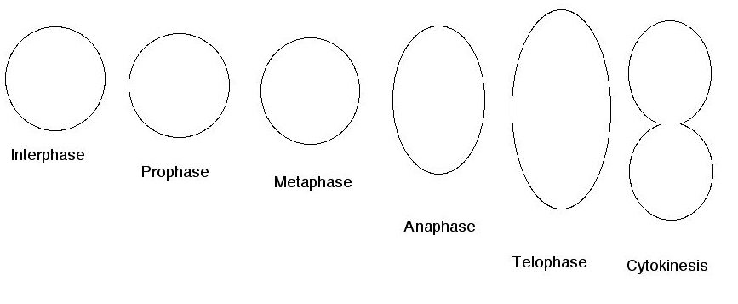

Meiosis
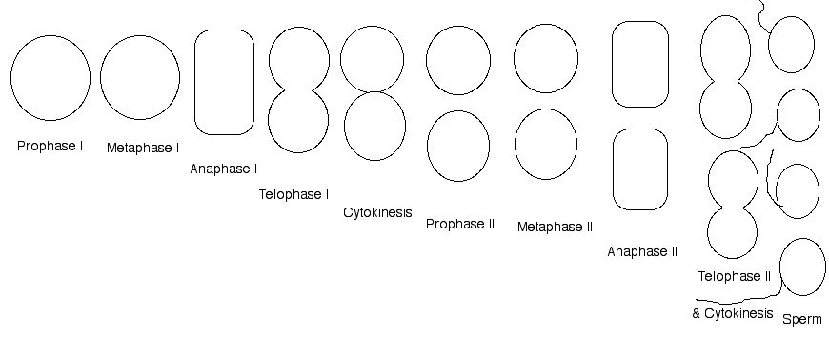

Asexual Reproduction
Budding | Drawing/Description
Regeneration | Drawing/Description
Vegetative Propagation | Drawing/Description
Binary Fission | Drawing/Description
Sporulation | Drawing/Description
Sexual Reproduction
Crossing Over | Drawing/Description
Random Assortment | Drawing/Description
Gene Mutation | Drawing/Description
Nondisjunction | Drawing/Description
Fertilization | Drawing/Description

