Name:
Muscular System Packet o’ Knowledge
Muscles to know:

Frontalis | Occipitalis | Sternocleidomastoid | Trapezius | Deltoid | Triceps | Flexor digitorum
Masseter | Orbicularis oculi | Orbicularis oris | Deltoid | Pectoralis major | Pectoralis minor | Biceps brachii
Serratus anterior | Rectus abdominus | Tensor fascia latae | Gracilis | Latissimus dorsi | Gluteus maximus | Sartorius
Semitendinosis | Semimembranosis | Biceps femoris | Tibialis anterior | Soleus | Gastrocnemius | Vastus medialis
Vastus lateralis | Rectus femoris | Adductor group | Brachioradialis | Teres group
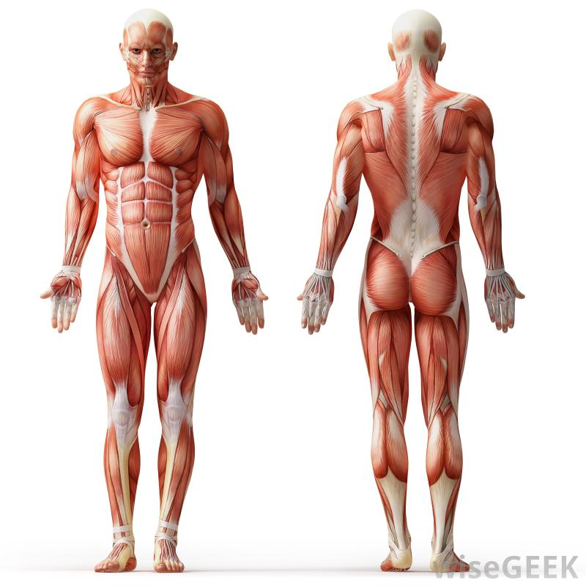

Epimysium | Bone | Tendon | Perimysium | Fascicle
Blood vessel | Endomysium | Muscle fiber
** Terms do not necessarily correspond with a number on the image

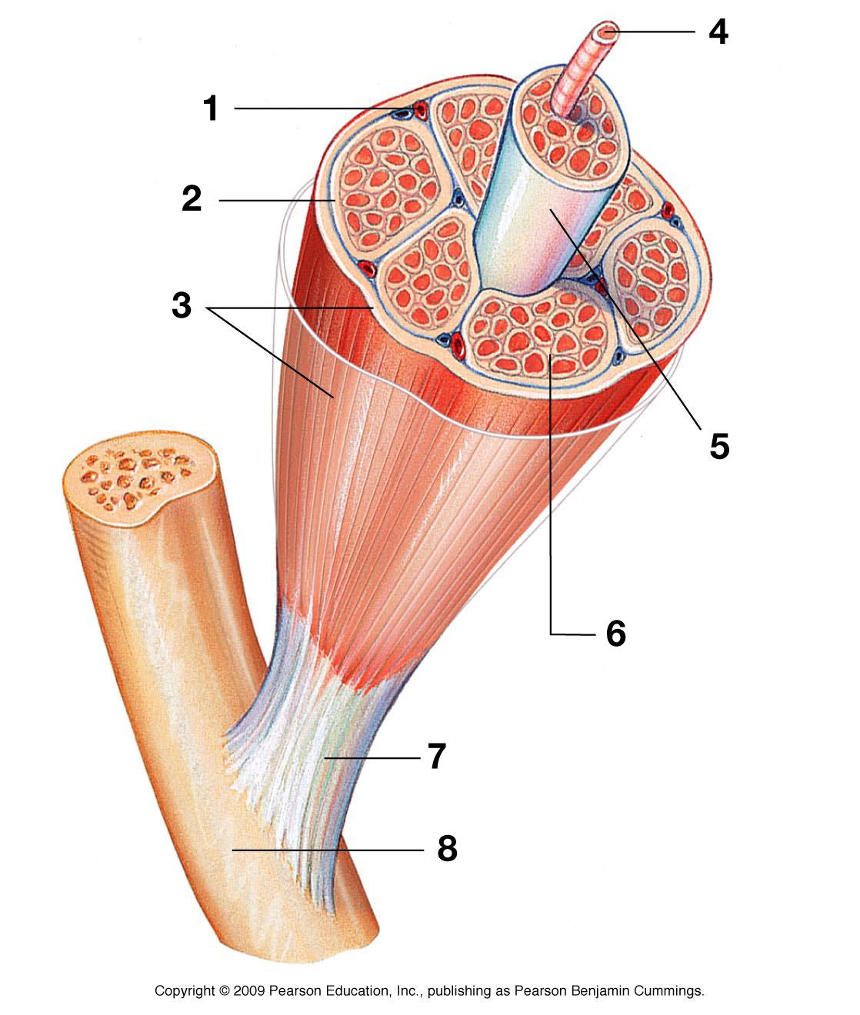

Actin (thin) | Myosin (thick) | Z disc | H zone | I band | A band
Sarcomere | M line

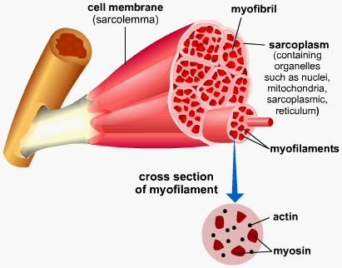
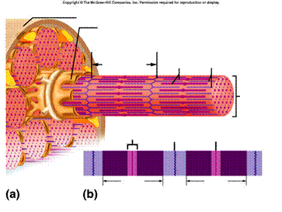

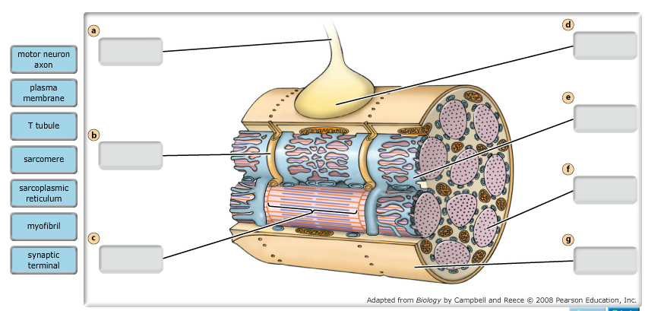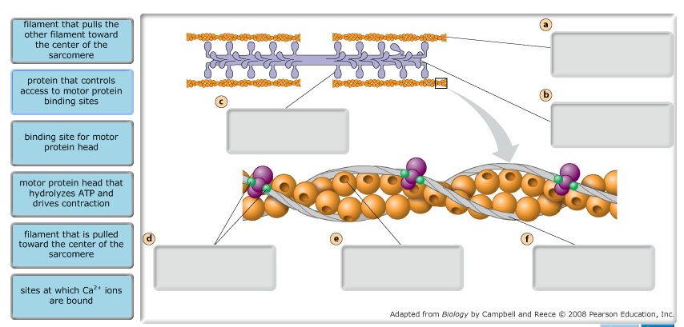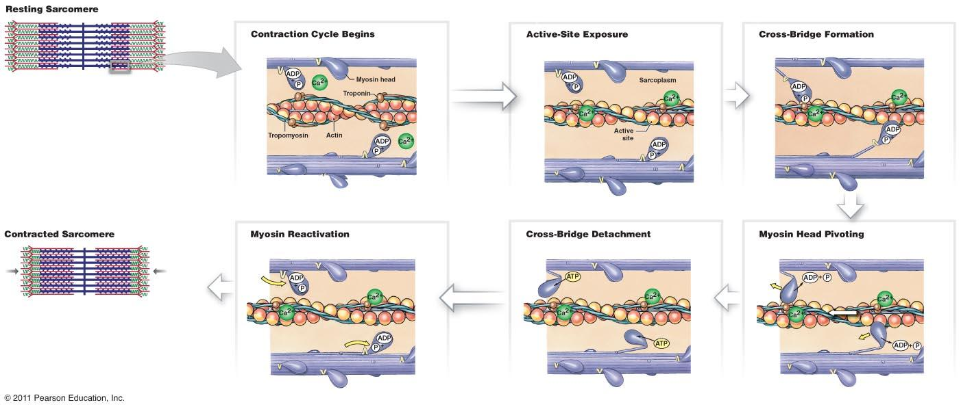
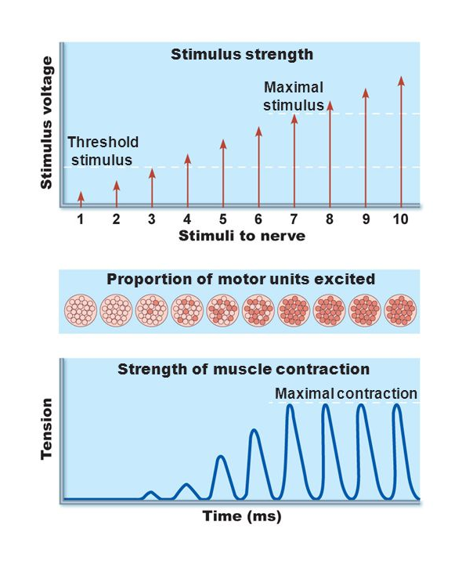
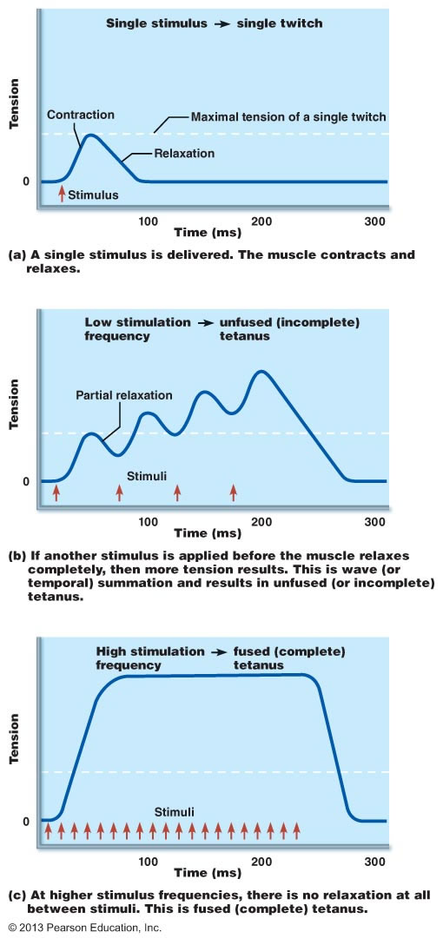
Isotonic:

Isometric:

