Match the following:
- Element that serves as the actual “go” signal for muscle contraction F
- Neurotransmitter substance released by the neuron to stimulate muscle cell A
- Normally stored in the sarcoplasmic reticulum F
- A metabolic pathway that produces water, carbon dioxide, and ATP, and provides for a large amount of ATP per glucose because oxygen is present B
- Element that “rushes” into the muscle cell after stimulation from the nerve E
- acetylcholine b. aerobic respiration c. enzymes d. anaerobic respiration e. potassium ions f. calcium ions g. sodium ions
- Muscle used to turn head H
- “Kissing” muscle D
- Chewing muscle F
- Muscle used to furrow eyebrows H
- Shoulder muscle G
  - occipitalis b. zygomaticus c. trapezius d. orbicularis oris e. orbicularis oculi f. masseter g. deltoid h. frontalis i. pectoralis major j. sternocleidomastoid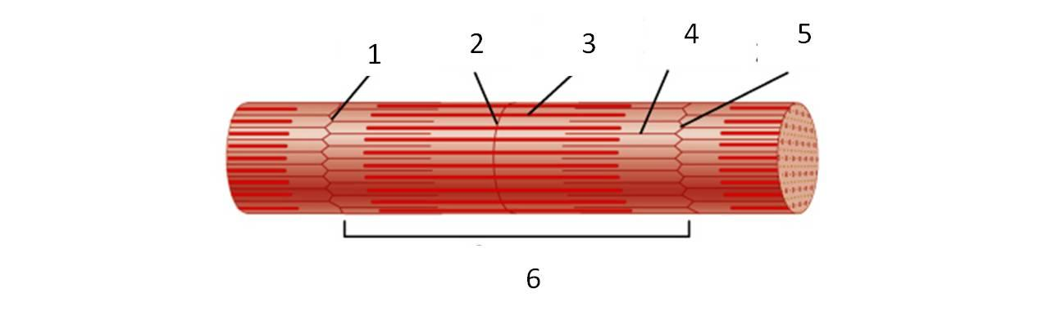
- Represents the H zone
- Will move towards each other during contraction (2 numbers)
- Muscle tissue that is involuntary:
  - skeletal muscle only
  - smooth muscle only
  - skeletal and smooth
  - cardiac and smooth
- Which of the following is not a function of the muscular system:
  - producing movement
  - maintaining posture
  - fat synthesis
  - generating heat
- A sarcomere is:
  - a nonfunctional unit of skeletal muscle
  - the unit between 2 z-discs
  - the light and dark striations of muscle tissue
  - made of solely actin
- Which of the following are in the proper order from superficial to deep?
  - Epimysium, muscle belly, perimysium, fascicle, endomysium, muscle fiber, myofibril, sarcomere
  - Endomysium, muscle belly, perimysium, fascicle, epimysium, muscle fiber, myofibril, sarcomere
  - Epimysium, muscle belly, endomysium, fascicle, perimysium, muscle fiber, myofibril, sarcomere
  - Epimysium, muscle belly, perimysium, sarcomere, endomysium, muscle fiber, myofibril, fascicle
- Which of the following groups of terms is placed in the correct order from largest to smallest?
  - myofilament, myofibril, muscle fiber, fascicle
  - fascicle, muscle fiber, myofibril, sarcomere
  - muscle fiber, myofibril, sarcomere, fascicle
  - fascicle, sarcomere, myofibril, myofilament
- A motor unit consists of:
  - a skeletal muscle and all the neurons that supply it
  - all the neurons that stimulate a single action
  - all the skeletal muscles in a single movement
  - a neuron and all the skeletal myofibrils it stimulates
- In muscle contraction, calcium apparently acts to:
  - increase the action potential transmitted along the sarcolemma
  - release myosin from actin
  - expose binding sites on actin
  - stimulate the relaxation of the sarcomere
- The mechanical force of contraction is generated by:
  - shortening of thick filaments
  - shortening of thin filaments
  - sliding of thin filaments past thick ones
  - an “accordion-like” folding of thick and thin filaments
- Acetylcholine is:
  - an ion pump
  - a source of energy for muscle contraction
  - a component of actin
  - a neurotransmitter
- During muscle contraction, myosin cross bridges attach to the active sites of:
  - myosin
  - actin
  - Z lines
  - H zone
- Which of the following are accessory proteins of actin?
  - Troponin and sarcoplasm
  - Troponin and myosin
  - Troponin and tropomyosin
  - Sarcoplasm and sarcolemma
- The striations of muscle cells are produced by:
  - a difference in thickness of the sarcolemma
  - the T tubules
  - the arrangement of myofilaments (actin and myosin)
  - the cocked position of myosin
- The condition of fatigue can be explained by:
  - insufficient quantities of ATP
  - all-or-none law
  - inadequate number of mitochondira
  - a total lack of ATP
- Creatine Phosphate functions in muscle cells to:
  - form a temporary chemical compound with actin
  - form a temporary chemical compound with myosin
  - cause a conformational change in actin and myosin
  - provide temporary, yet rapid, ATP production
- Muscle tone is:
  - the feeling of well being following an exercise
  - a state of sustained partial contraction resulting from use of muscles
  - the ability of a muscle to maintain a contraction for an extended amount of time
  - how rapidly muscles can contract and relax in succession
- Observe the list of muscle actions below. Which of them would not be classified as isotonic?
  - writing a letter
  - tying your shoe
  - pushing against a stationary object (ie. wall)
  - lifting a glass of water to your mouth
- The insertion of a muscle is:
  - immovable
  - movable
  - attached to 2 or more bones
  - a tendon
- Which of the following is completely true?
  - semimembranosus originates at the pelvis and inserts at the fibula
  - biceps brachii originates at the clavicle and inserts at the radius
  - deltoid originates at the humerus and inserts at the second cervical vertebrae
  - soleus originates at the femur and inserts at the carpals
- Rigor mortis is a result of:
  - sodium entering the muscle cell
  - increased stimulus on muscle cells
  - decreased stimulus on muscle cells
  - an excess of calcium being released by the sarcoplasmic reticulum
- Which criteria is not used in naming muscles?
  - Action of the muscle
  - Method of attachment
  - Directions of fibers in the muscle
  - Relative size of muscle
- Muscular dystrophy results in:
  - muscle tone
  - muscle fatigue
  - muscle atrophy
  - muscle growth
- While doing “jumping jacks” during gym class, your arms and legs move away from the midline of your body. This motion is called:
  - extension
  - flexion
  - abduction
  - adduction
- Which of the following muscles is involved in abduction?
  - latissimus dorsi
  - occipitalis
  - biceps brachii
  - tensor fascia lata
- Paralysis of which of the following would make an individual unable to flex the anterior thigh?
  - biceps femoris
  - adductor
  - tibialis anterior
  - rectus femoris
- Which of the following is true?
  - Muscles can only pull, they never push
  - Muscles do not need to cross a joint
  - The insertion moves away from the origin during flexion
  - Muscles readily regenerate
- Muscle cramps are caused by which of the following:
  - Dehydration
  - Thyroid disorders
  - Overuse
  - All of the above
- 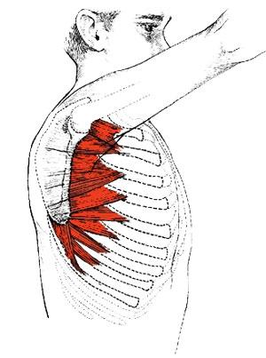
- 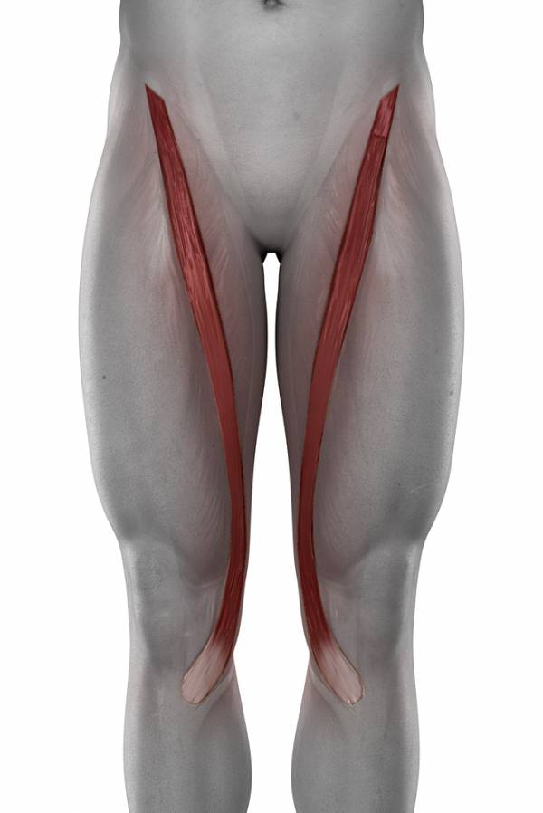
- 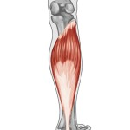
- 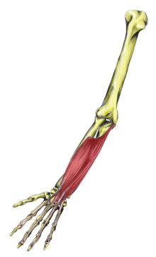
Short Answer:
- Write about one of the homeostatic imbalances of the muscles. What does it affect? What is the result? How does this affect activity?
- What are the 5 golden rules of skeletal activity?
- Explain the difference between isometric and isotonic exercises. Provide a description and examples of each. How are they beneficial?

