Nervous System Packet o’ Knowledge

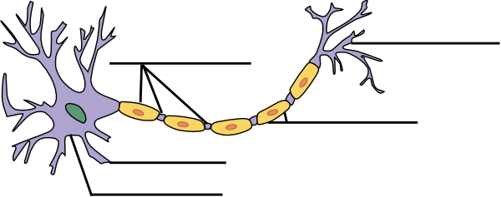
Label the axon terminals, nodes of Ranvier, dendrite, myelin, cell body

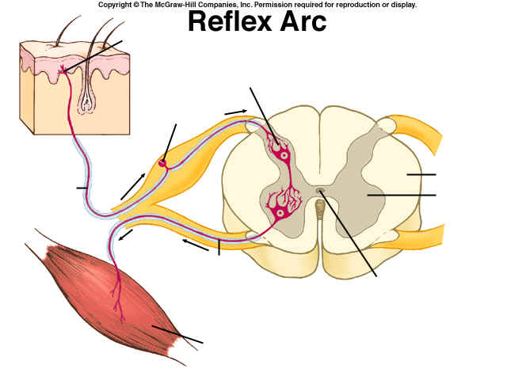
Label the interneuron, effector, receptor, motor neuron, sensory neuron, grey matter, white matter, ventral root and dorsal root
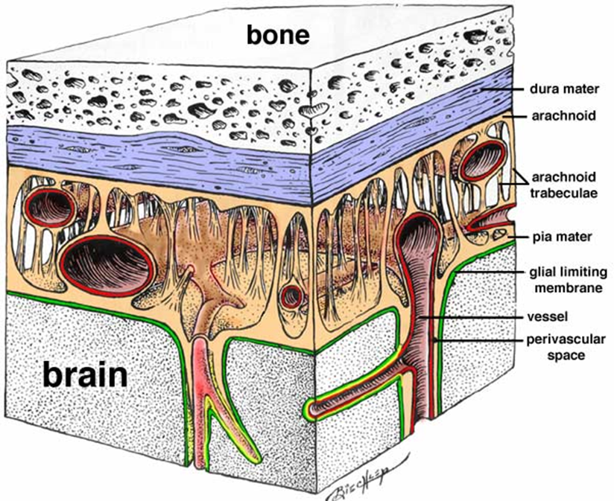
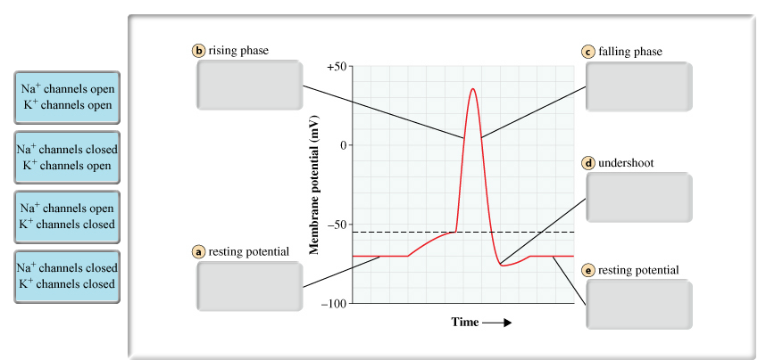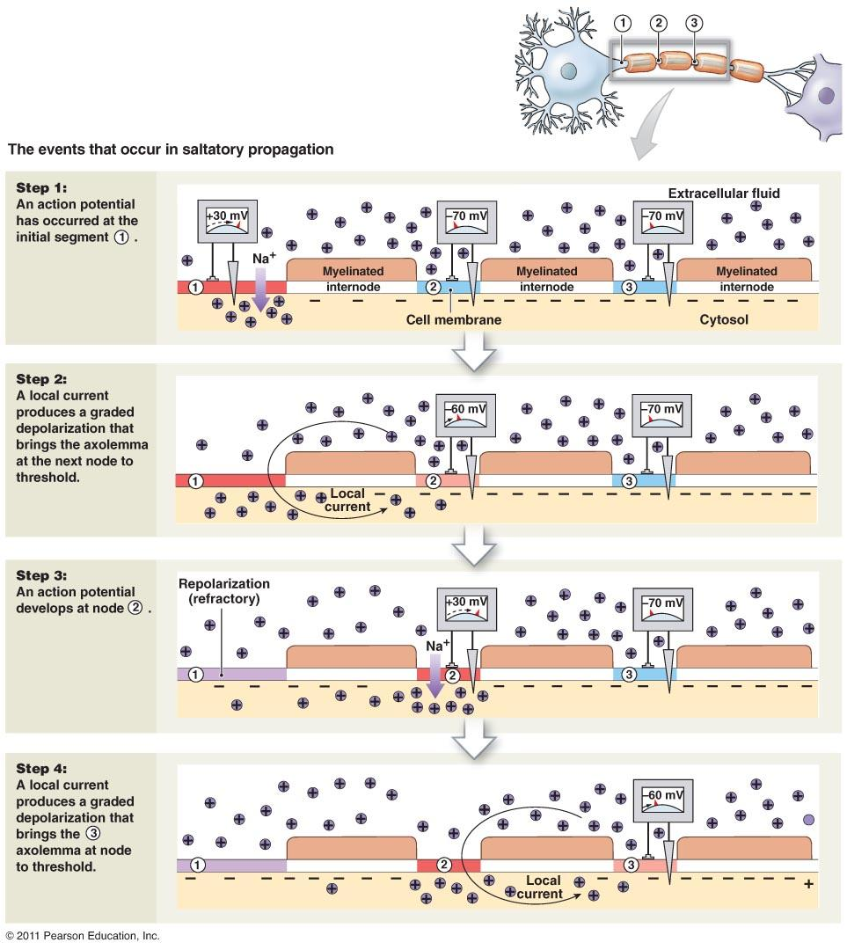
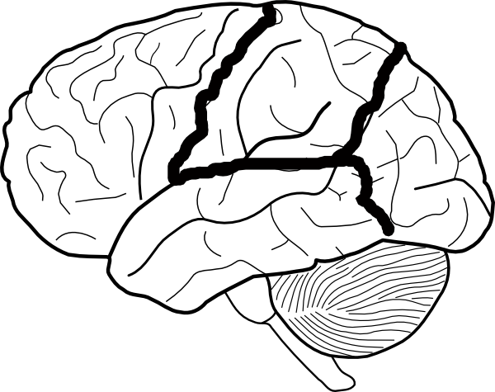
Label sulci, gyri, frontal lobe, parietal lobe, temporal lobe, occipital lobe, cerebellum, brain stem, central fissure/sulcus, and lateral fissure/sulcus
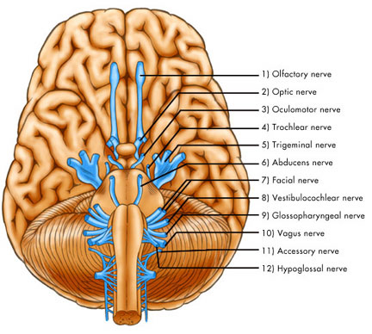

Cranial Nerve | Origin/Course | Function
- Olfactory
II. Optic
III. Oculomotor
IV. Trochlear
V. Trigeminal
VI. Abducens
VII. Facial
VIII. Vestibulocochlear
IX. Glossopharyngeal
X. Vagus
XI. Accessory
XII. Hypoglossal

