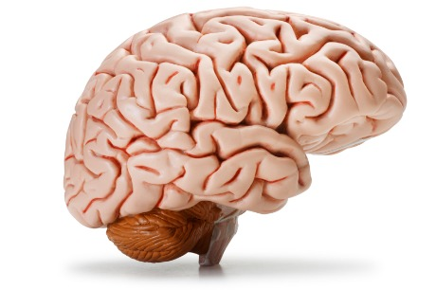
Project WHOOOOOOSH
Action Potentials are a confusing and complex topic, but central to understanding the nervous system. This project will have a series of parts to help you remember how our brains orchestrate our body’s functions!
Part 1: Write the steps of a nerve impulse.
Using page 211 in your books and the worksheet provided, read through the process of a neural impulse and write the steps. Use your own words, but make sure to include the related terms below:

- Action Potential
- Hyperpolarization
- Polarization
- Depolarization
- Repolarization
- Rising phase
- Falling phase
- Refractory Period
- Neurotransmission
- Dendrite
- Neurotransmitter
- Cell body
- Axon
- Sodium
- Potassium
- Protein (Na/K pump)

Make sure to number each step, as this will be an important in part 2.

Part 2: Label the graph
Using your list of steps, label the action potential graph in the correct order to correspond to the events in the neural impulse. You will be provided with a graph to label.

Part 3: Connotation Ladder
For each step of a neural impulse, you will choose one word to represent the event. You will also choose an image to associate with the word. For example, if I were describing the refractory period, I might use the word “frozen” and an ice cube to display that the neuron is stuck in a rested state and cannot fire until it reaches -70mV again. Do not use the same word twice and choose words that will help you to remember each step. This may be a beneficial memorization/study tool for the test!

Project WHOOOOOOSH
Action Potentials are a confusing and complex topic, but central to understanding the nervous system. This project will have a series of parts to help you remember how our brains orchestrate our body’s functions!
Part 1: Write the steps of a nerve impulse.
Using page 211 in your books and the worksheet provided, read through the process of a neural impulse and write the steps. Use your own words, but make sure to include the related terms below:

- Action Potential
- Hyperpolarization
- Polarization
- Depolarization
- Repolarization
- Rising phase
- Falling phase
- Refractory Period
- Neurotransmission
- Dendrite
- Neurotransmitter
- Cell body
- Axon
- Sodium
- Potassium
- Protein (Na/K pump)

Make sure to number each step, as this will be an important in part 2.

Part 2: Label the graph
Using your list of steps, label the action potential graph in the correct order to correspond to the events in the neural impulse. You will be provided with a graph to label.

Part 3: Connotation Ladder
For each step of a neural impulse, you will choose one word to represent the event. You will also choose an image to associate with the word. For example, if I were describing the refractory period, I might use the word “frozen” and an ice cube to display that the neuron is stuck in a rested state and cannot fire until it reaches -70mV again. Do not use the same word twice and choose words that will help you to remember each step. This may be a beneficial memorization/study tool for the test!

