Male Reproductive System |  | Female Reproductive System
Primary Characteristics |  | Primary Characteristics
Penis |  | Vagina
Urethra |  | Cervix
Vas Deferens |  | Uterus
Epididymis |  | Fallopian Tubes
Scrotum |  | Ovary
Prostate |  | Labia
Urethra |  | Clitoris
 |  | Hymen
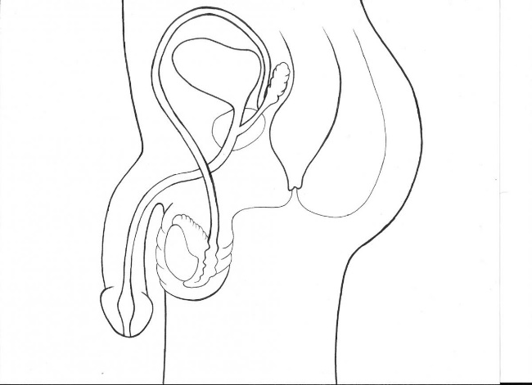 |  | 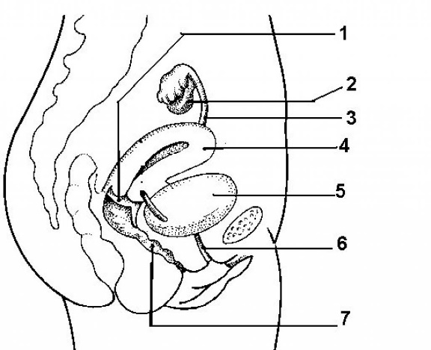
Secondary Characteristics |  | Secondary Characteristics
Spermatogenesis |  | Oogenesis

Menstrual Cycle
Menses | Proliferative | Secretory
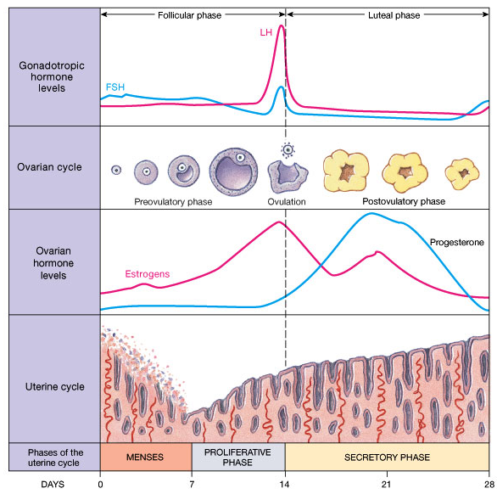
Stages of Pregnancy & Development
Fertilization | Embryonic Development | Fetal Development | Childbirth
