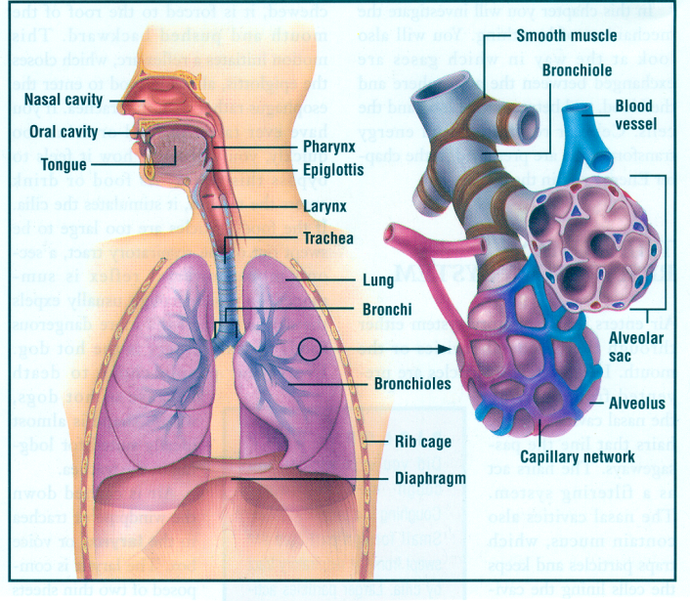
The Respiratory System Review Sheet
- How are the cardiovascular system and the respiratory system related?
The respiratory system provides the oxygen to the blood of the circulatory system. The circulatory system removes CO2 as waste through the respiratory system
- What are the functions of the nose and what structures allow for this?
- What is the main function of the trachea?
The main function of the trachea is to act as the windpipe to direct air to the lungs

- What is the function of the rings of cartilage surrounding the trachea?

- What is the main function of the larynx?
The larynx is the voicebox of the body and contains the epiglottis. This ensures food does not enter the airway

- What is the relationship between the bronchus, the bronchi and the bronchioles?

- Why is breathing through your nose and out through your mouth a more effective way of gas exchange?
The nose will humidify and warm the air for better gas exchange. Also, the nose is lined with mucous membranes, while the mouth will dry out if you continue to breathe through it.

- Why does the air need to be filtered and humidified?
- What is the main function of the lungs?
The main function of the lungs is gas exchange of oxygen and carbon dioxide

- What is the difference between the left and right lung?

- What is the function of the pharynx? What are the three regions of the pharynx?
The pharynx is your throat and directs food and air. Three regions of the pharynx include nasopharynx, oropharynx, and laryngopharynx

- What are alveoli and how do they operate? Why are they covered in a slippery material (called surfactant)?

- What is the epiglottis? What is the glottis?
The epiglottis is a covering in the larynx that directs food to the esophagus and air to the trachea. The glottis is a portion of the larynx that assists in voice projection

- The capillaries and alveoli work together to exchange gases. Draw a diagram depicting the flow of gases between the two. The exchange of gases occurs through what process?

- What factors allow for the exchange of gases between the blood cells in the capillaries and the alveoli? What type of epithelium are the capillaries and alveoli made of and why?
The walls of the alveoli are one cell thick, made of simple cuboidal epithelium. This allows for rapid gas exchange to the capillaries that surround each alveoli

- The exchange of gases occurs through what process? Explain the process.

- What factors affect respiration?
Age, Gender, Level of Physical Activity, Genetics

- What is the formula for vital lung capacity? What does each component of the formula represent?

- Why is there a residual volume of air inside your lungs?
The residual volume inside of your lungs allows for gas exchange to occur between breaths and ensures your alveoli are always inflated.

- What is the diaphragm?
- Describe how the chest and diaphragm work together to move air in and out of the lungs.
The diaphragm and muscles of the chest work together to force air in and out of the lungs. As the lungs expand to breathe air in, the diaphragm contracts. As the lungs release air and deflate, the diaphragm will relax and form a U shape.

- How are oxygen and carbon dioxide carried in the blood stream?

- Which part of your brain is responsible for controlling breathing?
Medulla oblongata

- Why is carbon monoxide so dangerous?
- Why is exercise good for the respiratory system?
Exercise is good for the respiratory system because it increases the amount of oxygen that is required by the body cells, causing you to breathe faster and your heart to pump harder. Maintaining exercise for an extended time will strengthen the heart and allow oxygen to be utilized more efficiently in the body.

- Explain emphysema and chronic bronchitis. How are the lungs/airways affected in each?

- What materials can be found in a cigarette?
Battery acid, Arsenic (poison), Rocket fuel, Paint, Sewer Gas, etc.

- How does smoking affect the lungs? What other parts of the body can be affected?

- How are the lungs affected in asthmatic individuals?
Asthma causes the airways to decrease in diameter, or narrow. This prevents efficient movement of air to the lungs.
