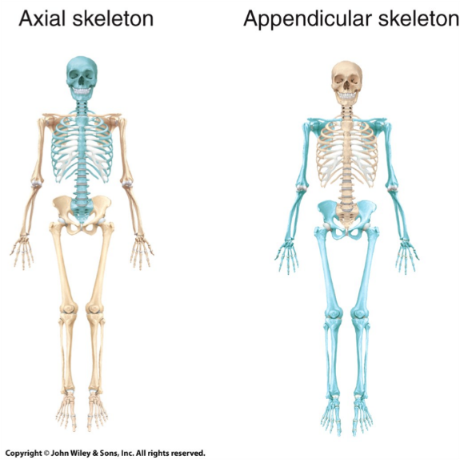
Skeletal System=________________________________________________
Functions of Bones:
_________________ body and cradle soft organs
_________________ vital organs
_________________ muscles move bones
_________________ of minerals (Ca and P) and growth factors
______________________________ in bone marrow
______________________________

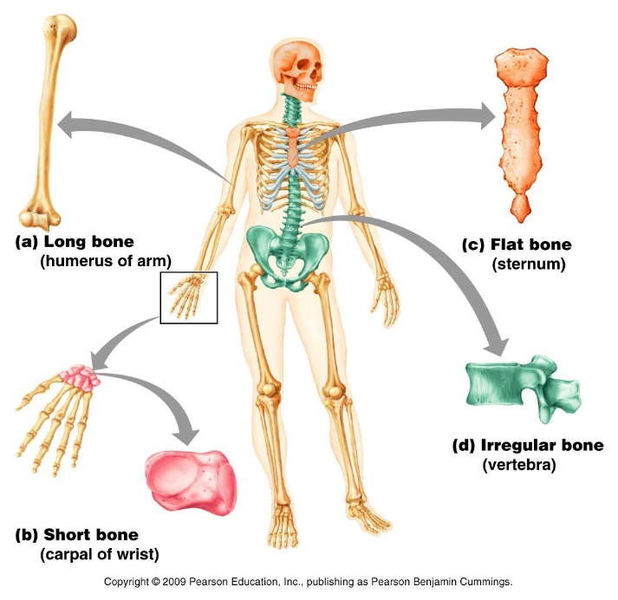
Classification | Description | Example
Long bones
Short bones
Flat bones
Irregular bones
Adult= ____________
Types of bone tissue:
________________ bone: outer layer – dense & solid
________________ bone: inner layer - open spaces, marrow
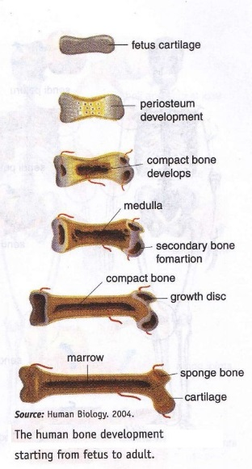
Features: Very hard (calcium salts), Light weight, Ability to resist tension and forces (collagen fibers)
Bone Development
__________________________ (ossification): bone tissue formation
Stages:
- Begins at 8 weeks gestation
- Start as ____________________ → replaced by bone
- Post-natal bone growth → early adulthood
- Epiphyseal plates: (growth plates) regions where long bones lengthen
- ___________________ growth: bones increase in thickness
- Bone modeling and repair – ______________
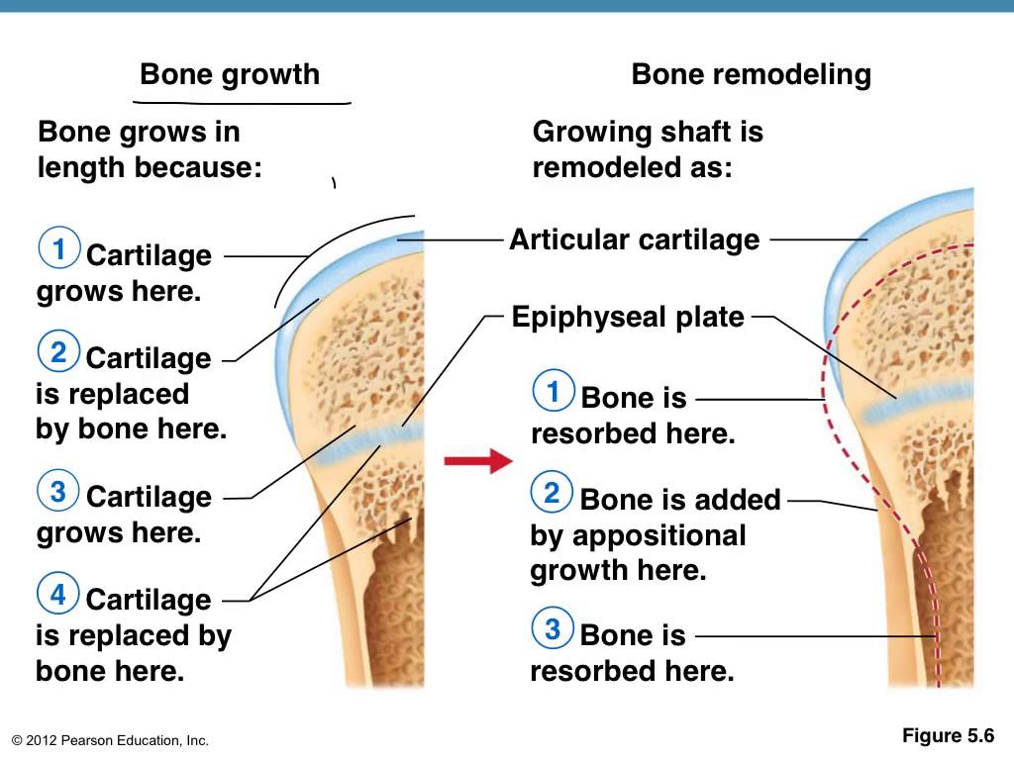
Hormonal control:
- Growth hormones: stimulate __________________ bone growth
- Thyroid hormone: control activity of growth _________________
- Testosterone & estrogens (at puberty): Adolescent growth spurt
- Close epiphyseal plates → end growth
Bone cells:
- _____________________: bone-forming cells
- Osteocytes: mature bone cell (doesn’t divide)
- ______________________: dissolve/break down bone (bone resorption)
Fractures/Breaks
Classified by:
- Position of bone – nondisplaced (normal) or displaced (bone out of alignment)
- Completeness of break – complete (broken through) or incomplete
- Orientation to long axis of bone – linear (parallel to bone) or transverse (perpendicular to bone)
- If bone penetrates skin – open (compound) fracture or closed (simple) fracture
Fracture Type | Description | Drawing
Comminuted
Compression
Spiral
Epiphyseal
Depressed
Greenstick

