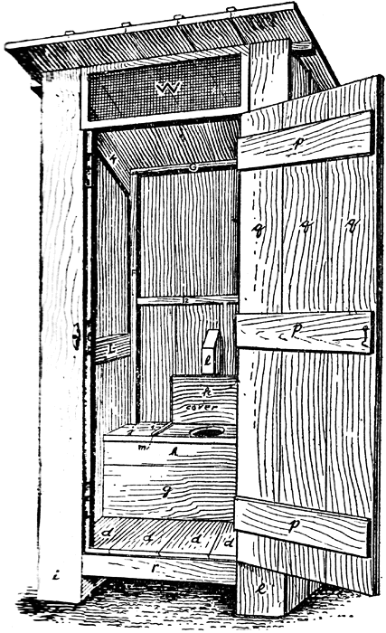
The Urinary System

The Urinary System is a group of organs in the body concerned with filtering out excess fluid and other substances from the bloodstream. The Urinary system works with the other systems of the body to help maintain homeostasis. In this unit, you will learn about the organs of the system and how the kidney works to filter out toxic wastes produced by your body.
Access each of the sites below to answer the questions that follow.
http://medicalcenter.osu.edu/patientcare/healthcare_services/urinary_bladder_kidney/anatomy_urinary_system/Pages/index.aspx
- What are three important functions of the urinary system?
- Identify each organ of the urinary system and describe the function of each.
- What is urea? Urine?
- List 4 facts about urine.
http://kidney.niddk.nih.gov/kudiseases/pubs/yourkidneys/
- Where are the kidneys located?
- Where does the actual removal of wastes occur?
http://science.howstuffworks.com/environmental/life/human-biology/kidney1.htm
- Describe the different parts of the kidney. Insert a diagram.
- Describe the five main parts of the nephron. Insert a diagram.
- Explain filtration in the nephron.
- Explain reabsorption in the nephron.

http://library.thinkquest.org/28807/data/excr11.htm

- How is urine formed?
View the following videos on how the urinary system works.
http://health.howstuffworks.com/human-body/systems/kidney-urinary/adam-200032.htm
http://www.youtube.com/watch?v=aQZaNXNroVY

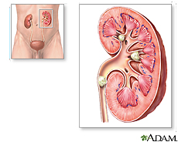
- Read about and explain each of the following kidney disorders:
http://www.healthline.com/channel/urinary-system-disorders.html
Cystitis
Urinary incontinence
Kidney stones
Polycystic kidney disease
Kidney failure
Interstitial cystitis
Urinary Tract Infections
Chronic renal failure
Diabetic nephropathy
Urinary tract obstruction
Glomerulonephritis
http://www.medicalnewstoday.com/articles/152902.php

- Explain kidney dialysis.
- Why is dialysis necessary?
- Name and describe the two types of kidney dialysis.
http://www.mayoclinic.com/health/urinalysis/MY00488/DSECTION=results
- What problem does each of the following indicate?
Acidity | Concentration
Protein | Sugar
Ketones | Bilirubin
Infection | Blood
Casts | Yeasts
Crystals

http://wps.prenhall.com/wps/media/objects/1552/1589499/web_tut/16_02/16_02_01a.swf
17. Read through and watch the animation on urine formation. Describe what happens in each step and what structures/molecules are involved:
Filtration
Secretion
Absorption

