Body Tissues
A. Tissues are ________________________________________
B. Four primary tissues types:
1. ____________ (covering)
2. ____________ (support)
3. ________________ (control)
4. ____________ (movement)

Epithelium
A. Found in different areas of the body, such as_______________, body linings, and glandular tissue.
B. Functions are for _____________ (skin), ______________ (small intestine), filtration (kidneys), and ___________ (glands).
C. Characteristics of epithelial tissue include:
1. Cells fit closely together
2. Tissue layer always has ___________________ (the apical surface) that is exposed to the
cavity of an internal organ or the body’s exterior.
3. The lower surface is bound by a ____________________.
4. ______________ (these tissues have no blood supply of their own)
5. __________________ if nourished.
D. Classification of epithelium
1. Number of cell layers
a. ___________ - one layer
b. ___________- more than one layer

2. Shape of cells
a. ___________- flattened
b. ___________- cube shaped
c. ____________- column- like

Types of Epithelium
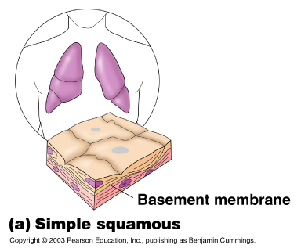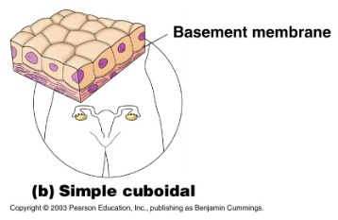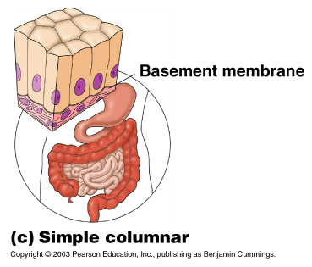

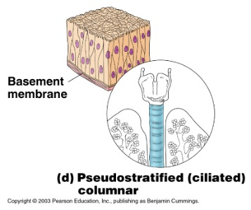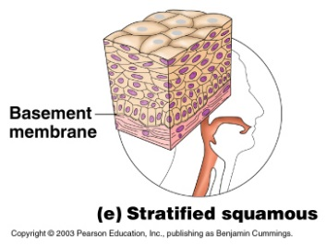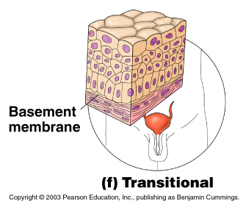

Connective Tissue
A. Found everywhere in the body, the ________________ and widely distributed tissue.
B. Functions include: binding tissues together, _________________
C. Characteristics of connective tissue:
1. Variations in blood supply- some tissue types are well vascularized (have good blood supply),
while some have a poor blood supply (____________________). Cartilage is avascular.
2. ________________________- the nonliving material that surrounds the tissue. (This is what makes connective tissue so different from other tissues.)
a. Matrix is composed of a _________________ (water, protein, and other molecules) and _________ (collagen, elastic, reticular).
b. The matrix allows connective tissue to act as a soft packing tissue around organs
(adipose tissue), to _______________________________________________
__________ (bones, tendons and ligaments).
D. Connective tissue types:
1. Bone (osseous) - composed of _____________, hard matrix, ________________ , large numbers of collagen fibers.
a. used to protect and support the body
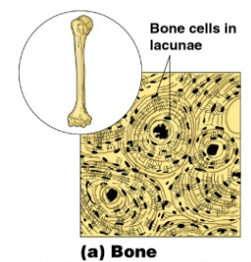
2. Hyaline Cartilage- most common type of cartilage, composed of _______________________
a. Entire _________________ is hyaline cartilage, but by the time of birth, most cartilage
is replaced by bone.
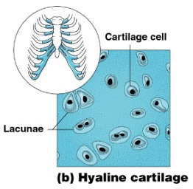
3. Elastic cartilage- provides _____________
a. Example- supports the _________________
4. Fibrocartilage- highly compressible
a. Example- forms cushion-like ___________________
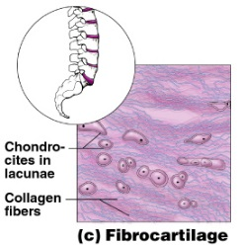
5. Dense connective tissue- main_______________________ fibers which form strong rope-like structures, (the collagen producing cells are called ________________)
a. Example- ___________ (attach muscle to bone), _______________ (attach bone to bone)
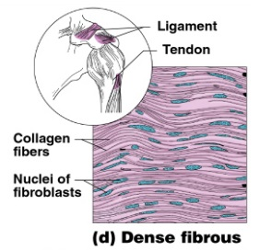
6. Areolar connective tissue-__________________________ connective tissue that serves as a kind of universal packing material between other tissues.

a. contains all fiber types,
b. can ________________ (this is the tissue that swells causing edema)
c. ______________________ and “glue” that holds internal organs together
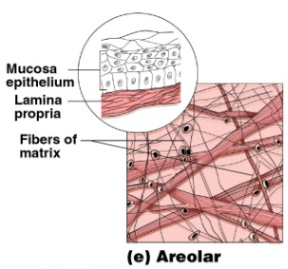
7. Adipose tissue- commonly ______________
a. matrix is Areolar tissue in which fat globules are predominate
b. these cells contain large ______________________
c. functions to ___________ the body, ____________ organs, and serves as a site of _________________
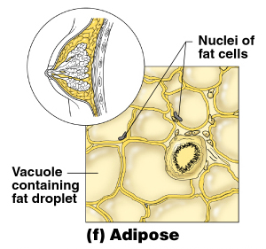

8. Reticular connective tissue-delicate network of interwoven fibers
a. forms internal network of __________________ (lymph nodes, spleen, and bone marrow)
9. Blood- blood cells surrounded by a _________________
a. fibers are visible during ___________
b. functions as the transport vehicle for materials

VI. Muscle Tissue
A. Functions to __________________
B. Three types are:
1. Skeletal muscle- voluntary, __________
2. Smooth muscle – involuntary, _________________
3. Cardiac muscle- ________________, only in heart, striated
i. _______________________ are the junctions that allow heart cells to rapidly conduct electrical impulses through the heart.
VII. Nervous Tissue-
A. Neurons and nerve support cells
B. Functions to _______________________ to other areas of body
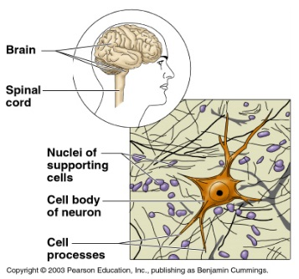
C. Located in __________________________ such as the brain, spinal cord and nerves
VIII. Tissue Repair (Wound Healing)
A. Two types of tissue repair:
1. Tissue regeneration is the__________________________ by the same kind of cells
2. ______________ occurs when repair by dense fibrous connective tissue called _________________ forms. Fibrosis occurs in cardiac and nervous tissues of the body.
B. The type of tissue repair depends on the___________________ and the ______________________

C. Steps in Tissue repair
1. Capillaries become very _____________
2. _____________________ and other substances seep into the injured area.
3. A clot is constructed to _______________________ (when the clot dries and hardens this forms the scab)
4. Formation of _____________________ (delicate tissue that is made of new capillaries that grow into the damaged area)
a. this tissue also contains ______________ that synthesize _______________ that bride the gap
5.____________________________; this covers an underlying layer of fibrosis (the scar)
D. The regeneration of tissue
1. Tissues that regenerate easily: _____________, fibrous connective, and bone
2. Tissues that regenerate poorly: __________________
3. Tissues that are replaced largely with_______________: cardiac and nervous tissue within the brain and spinal cord. Scar tissue lacks the normal flexibility of tissues which hinders the functioning.
E. As we age there is a ______________________________ of most tissues. The epithelia thin, the amount of collagen in the body declines which makes tissue repair less efficient, and nervous tissues begins to atrophy.

