Unit 4: Cell Respiration
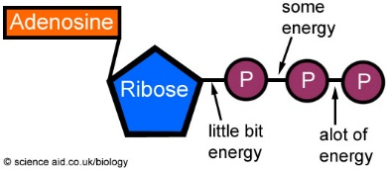
_____________________is the process by which the chemical energy of "food" molecules is released and changed into ATP.
How is ATP broken down to create energy?
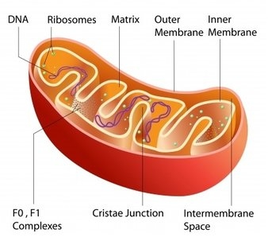
- Occurs in the __________________ of cells
Why is the mitochondria folded?

EQUATION:
ALL CELLS UNDERGO ________________________________
Aerobic Respiration | Anaerobic Respiration (AKA ______________)
- Requires _________ (O2)  - More efficient  - Produces ______ ATP molecules  - ______ is formed  Three Stages:  -  -  -  Where does this occur? | - Does not require ________ (O2)  - Less efficient  - Produces _____ ATP molecules  - _______ is not formed  2 Types:  Alcoholic: Happens in ________  _____ and ______ are produced  Lactic Acid: Happens in _________  _____________ is produced  Where does this occur?
Draw concept map of aerobic and anaerobic respiration:

- Both aerobic and anaerobic respiration make _______ and use __________

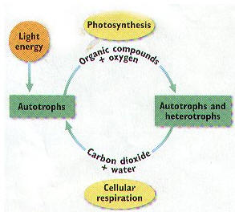
Draw relationship between photosynthesis and cell respiration:

