Disease | Description | Diagnosis | Treatment
Kidney stones
Incontinence
Urinary Tract Infections
Acute renal failure
Chronic kidney disease
Interstitial Cystitis (Painful bladder syndrome)
Urinary System Disorders
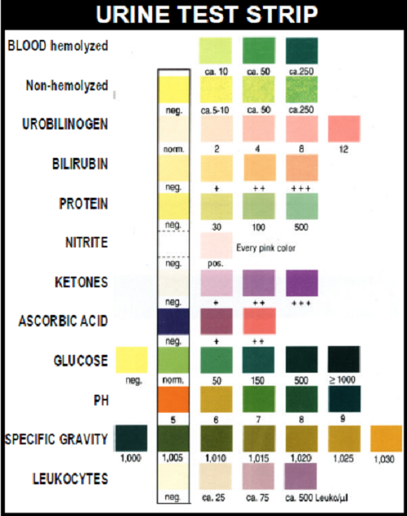
Urinalysis
What are the 3 types of urinalysis? List and briefly describe each.

What is specific gravity of urine? What does it mean if specific gravity is high? Low?

Urine Color | Indicates:
Green/blue
Clear, pale yellow
Dark yellow
Orange
Red
Brown
Cloudy
What is the normal pH of urine?
Complete the following charts:
Test | Positive result indicates:
Leukocytes
Nitrite
Protein
Glucose
Ketones
Urobiliogen
Bilirubin
Blood
Provide a short description of each:
- Hemoturia
- Proteinuria
- Glycosuria
- Ketonuria
- Bacteriuria

