Digestive System Study Guide
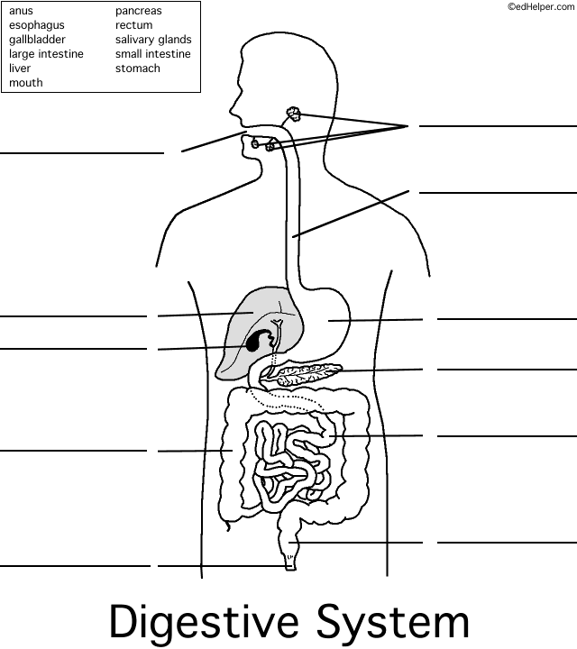
1. What are the functions of the digestive system? (List all 5)

2. What are the 2 types of digestion?

3. What is the pathway of food as it travels from the mouth to the rectum?

4. What is mastication?

5. What are the 3 main macronutrients? What are the 2 types of micronutrients?

6. What is the alimentary canal? What are the accessory organs of the digestive system?

7. Fill in the chart.
Enzyme | Location | Function
Amylase
Pepsin
Peptidase
Maltase
Sucrase
Lactase
Lipase
Protease
Bile salts

8. What is peristalsis?

9. What is a bolus? What is chyme? When do the names change?

10. What are rugae and how do they affect the stomach?

11. What is the cecum? Which small, vestigial organ is connected to the cecum?

12. What is metabolism? Explain the difference between catabolism and anabolism.

13. What are the 5 types and which macronutrient do they relate to?

13. Distinguish type I and type II diabetes.

14. What are the two hormones that the pancreas secretes? How do they relate to blood sugar?

15. What is obesity? What are some causes? What are complications? Why is it such a problem?

16. Distinguish bulimia nervosa and anorexia nervosa. Who is most affected by these disorders?

17. What are minerals and vitamins? How are they different? How do they impact the body?
Other materials to study:
Assignments to be turned in on test day:
- IIFYM Study
- Human Digestion in a Bag
- Vitamin/Mineral Webquest
- Where’s my food going/Organ function chart
- Reading Guide
- Notes
- Chart on Organ Function
- Encyclopedia of Digestive Disease
- Metabolism concept map
- IIFYM study

